**Assignment No:14**

**Title: Create an Elastic IP for an Instance.**

**Step-1:**

Log into AWS and open EC2.

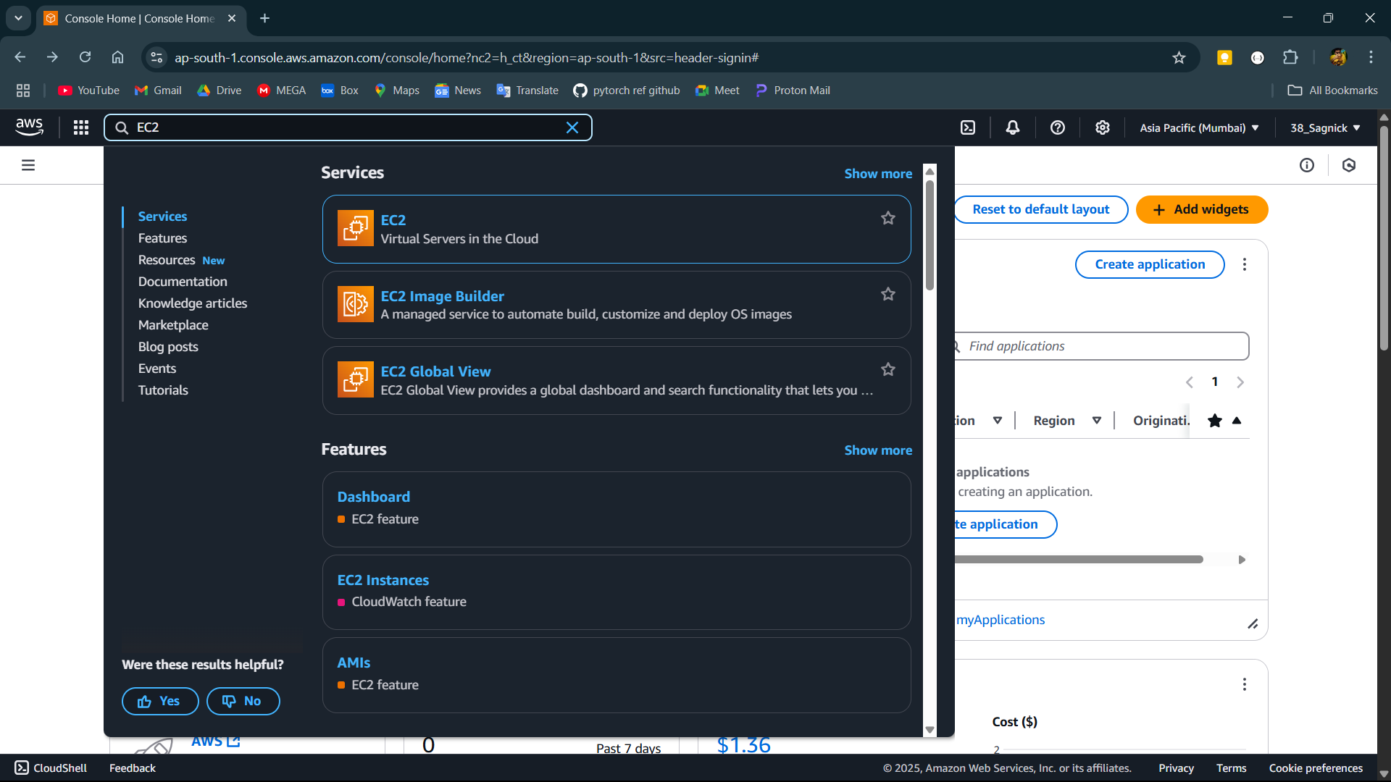

**Step-2:**

Click on Launch instance to create a new instance.

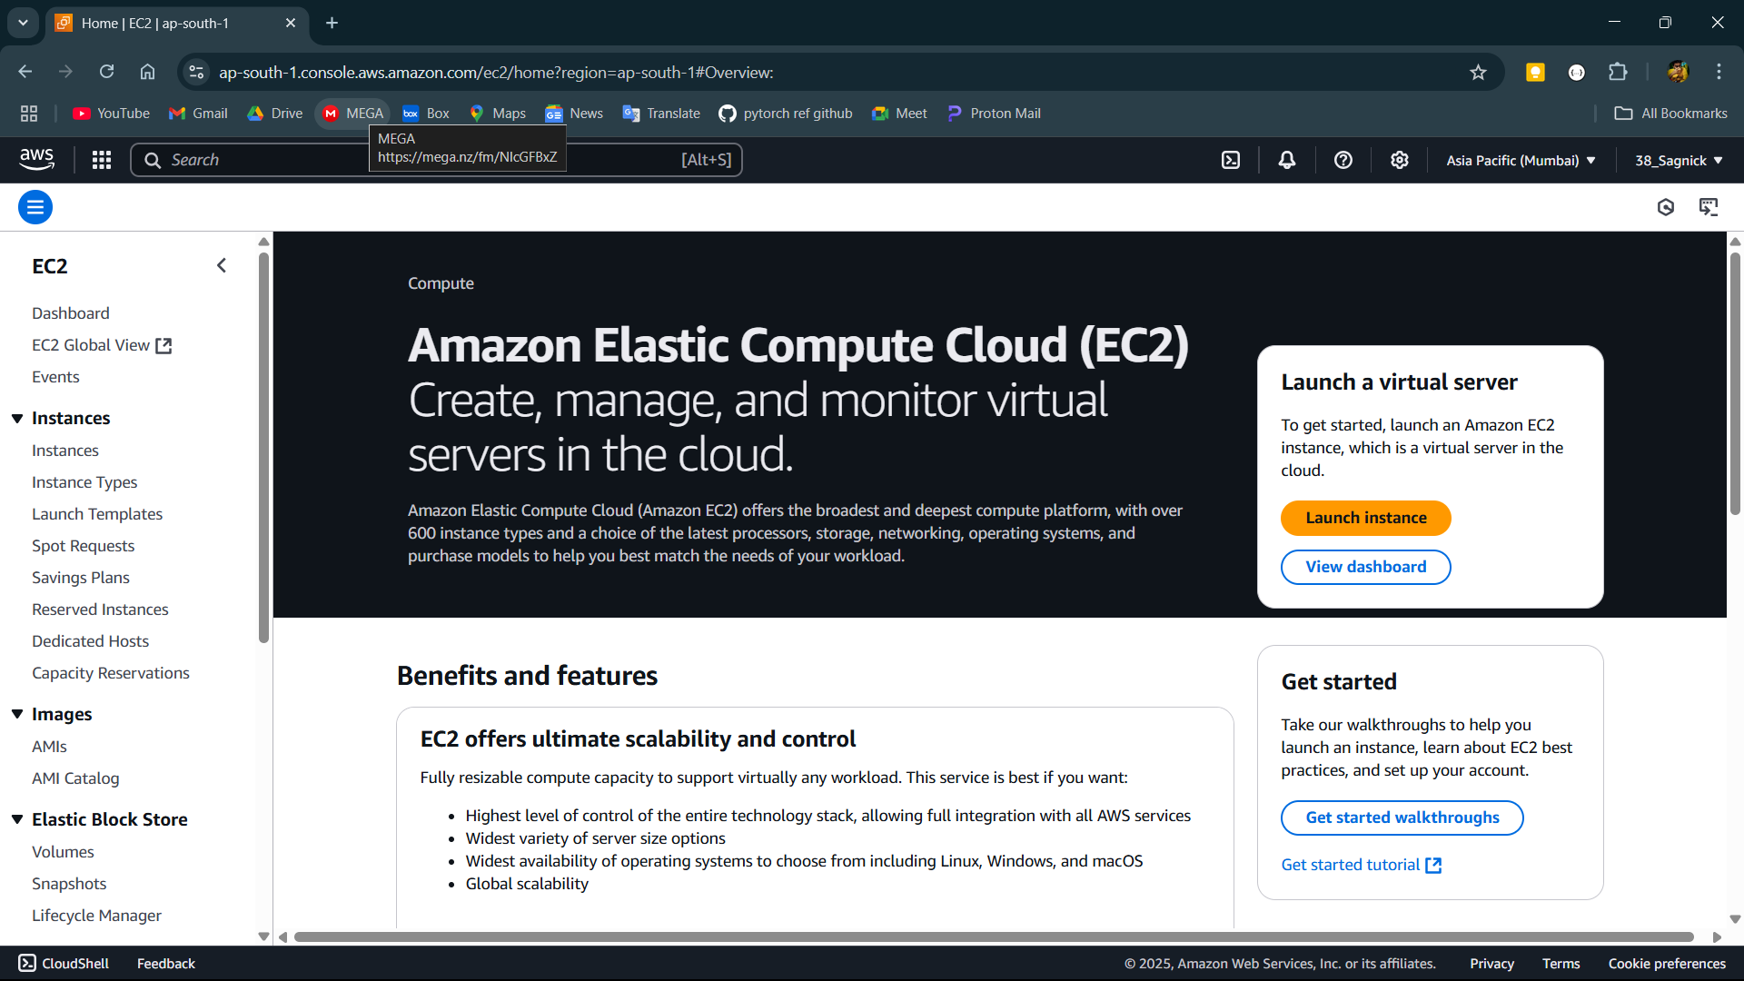

**Step-3:**

Create the instance and provide the user data if required.

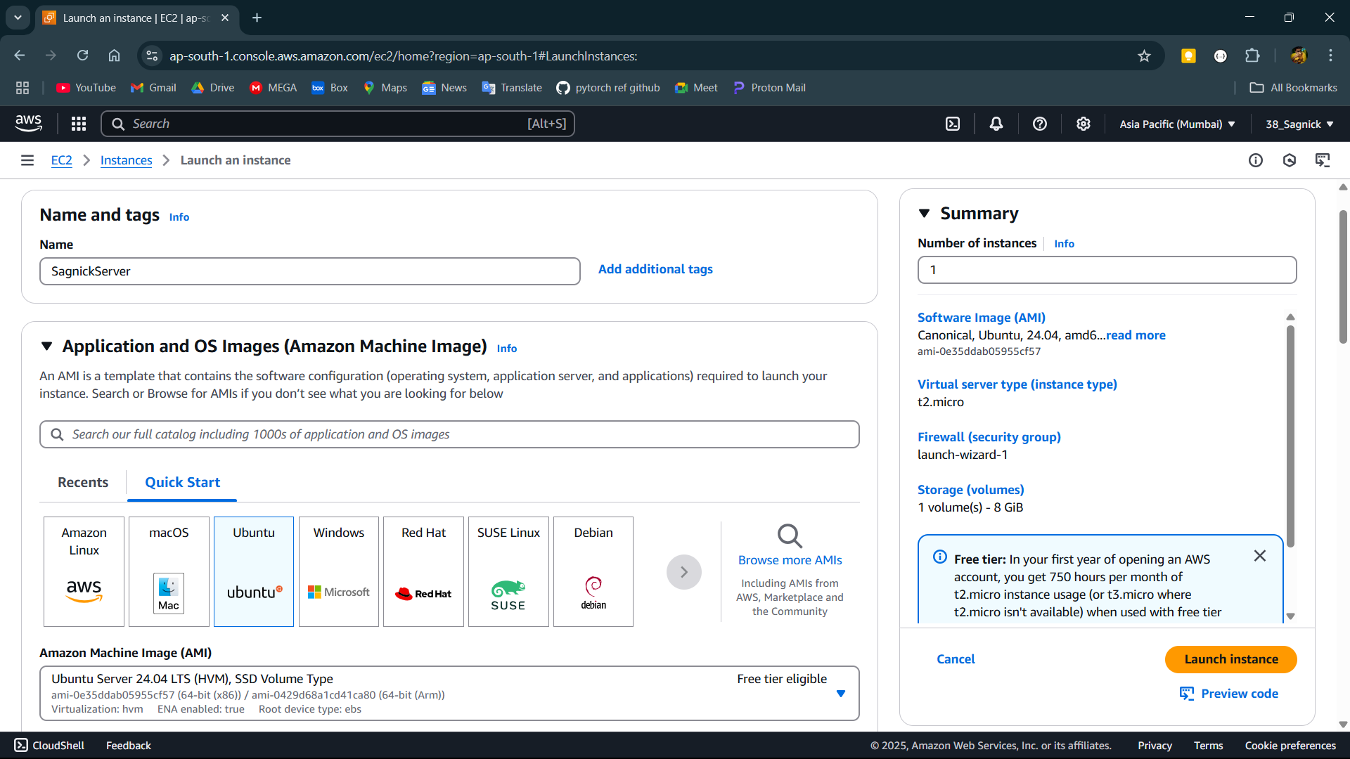

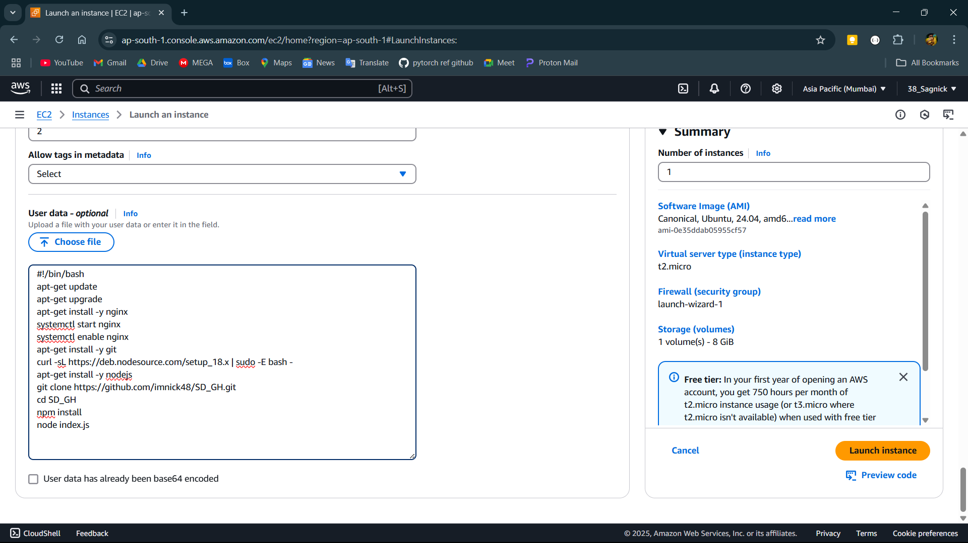

**Step-4:**

Now the IPv4 address changes if the server turns off.

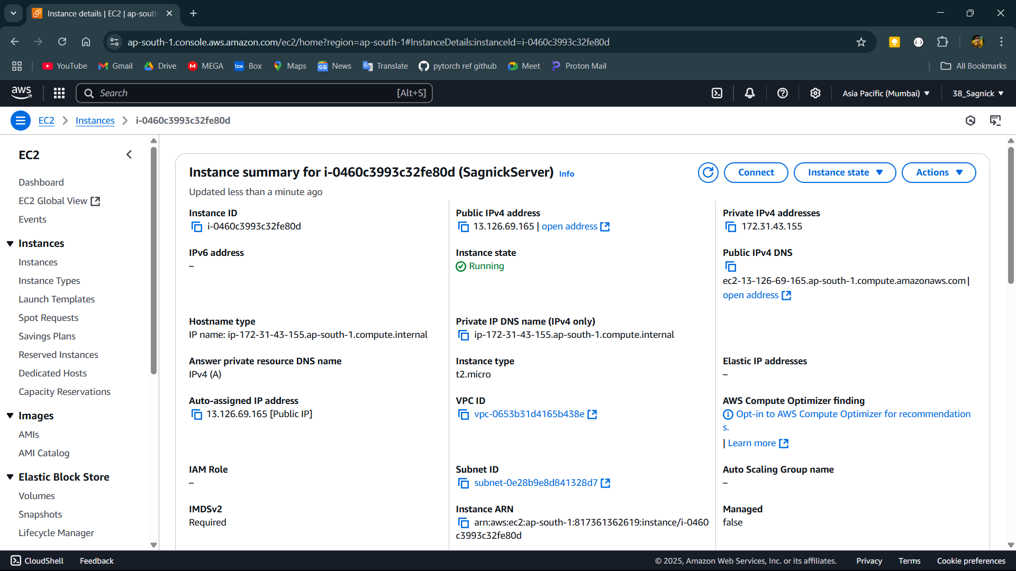

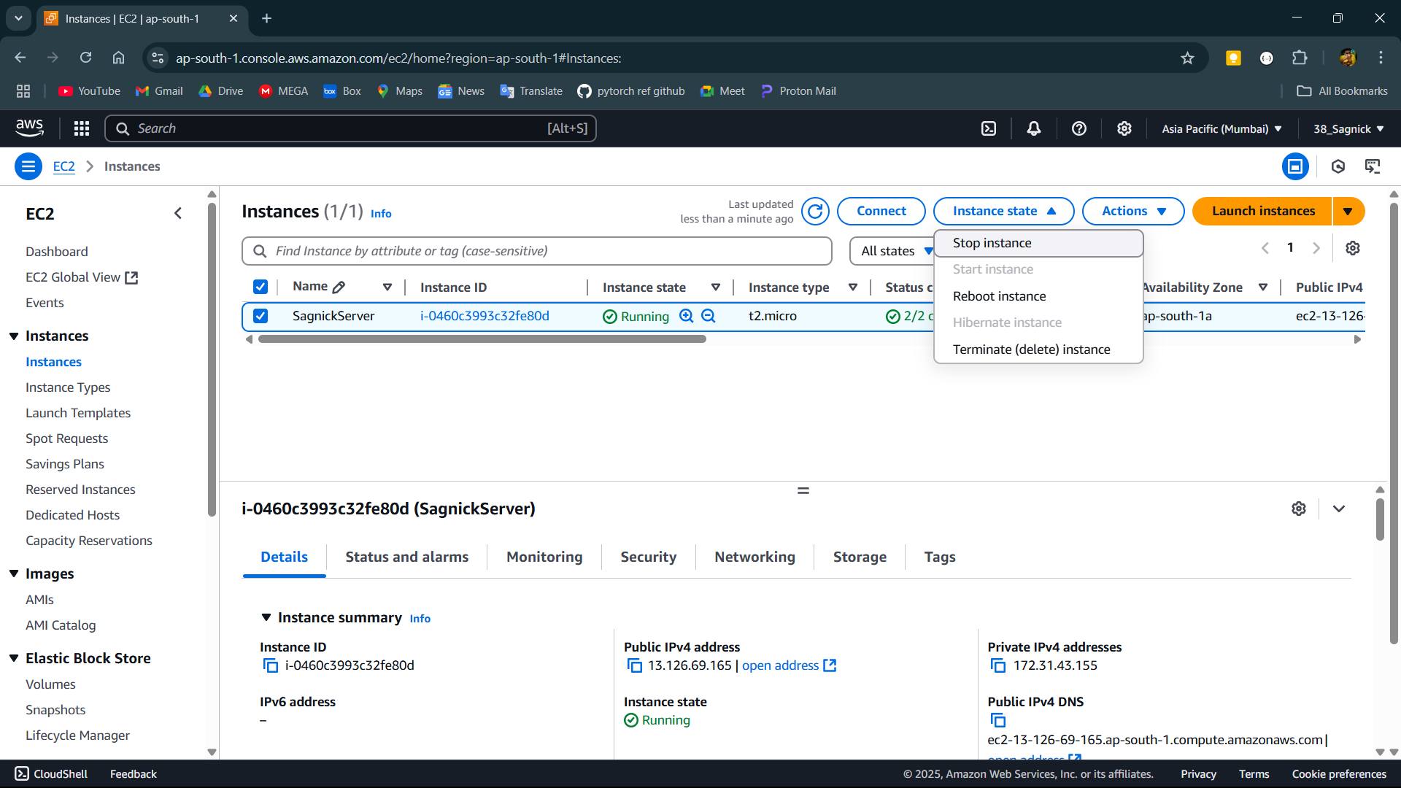

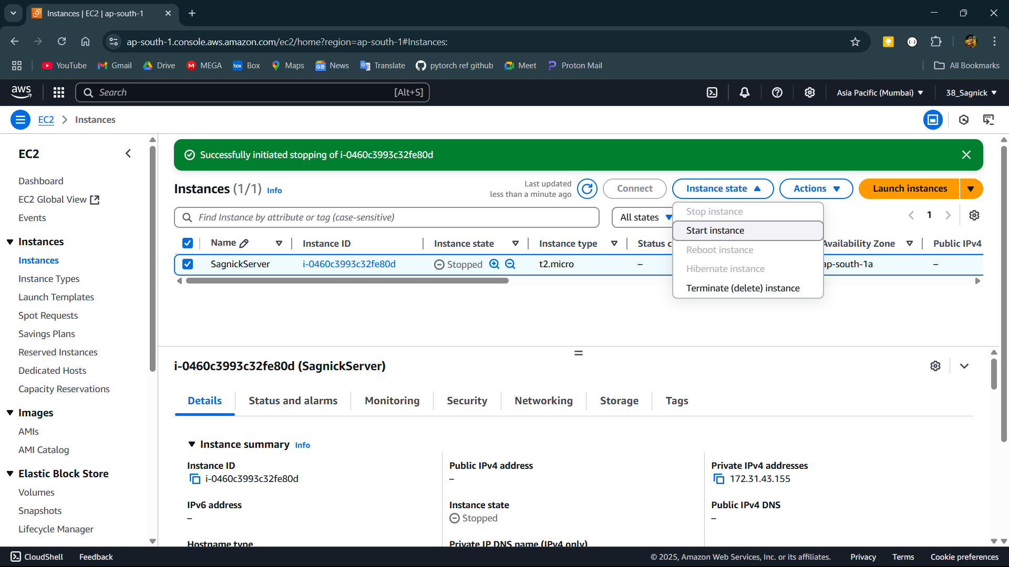

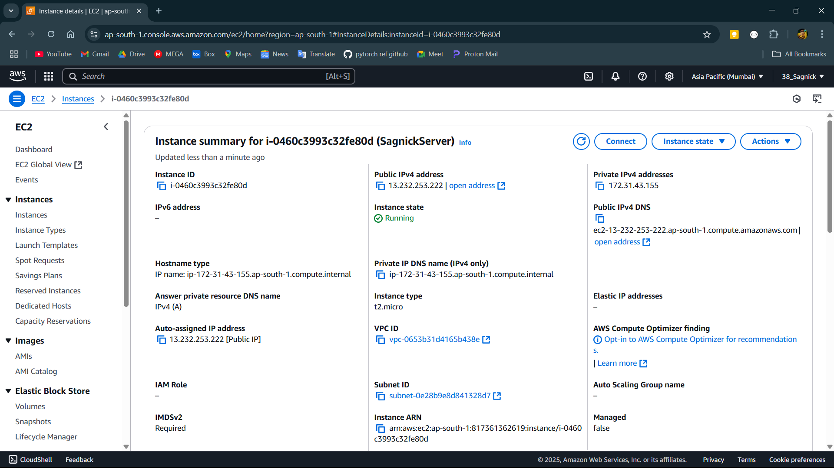

**Step-5:**

Open the Elastic IPs in the left side.

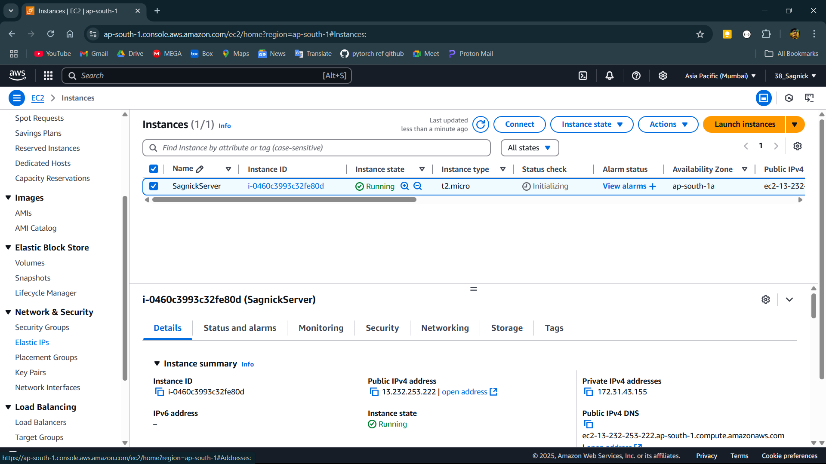

**Step-6:**

Now go to allocate elastic ip address then allocate.

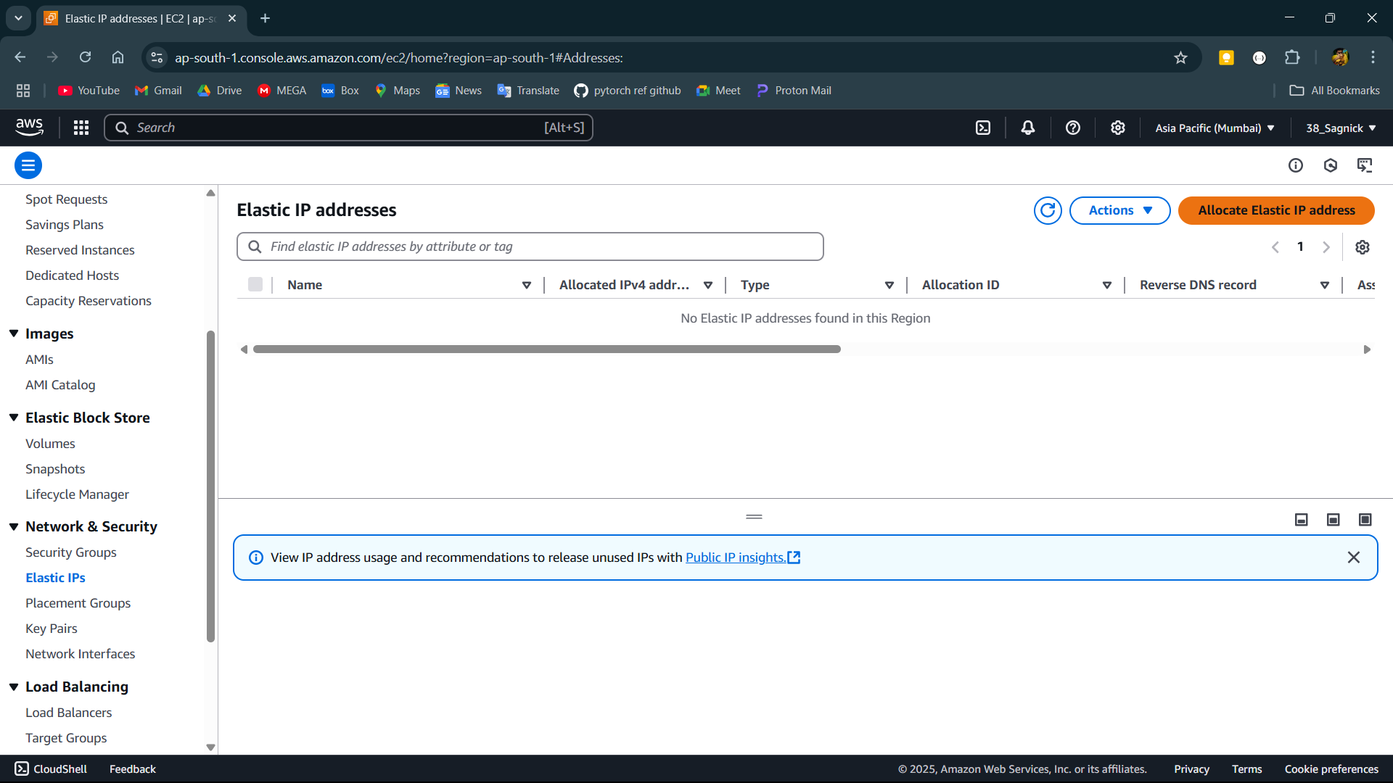

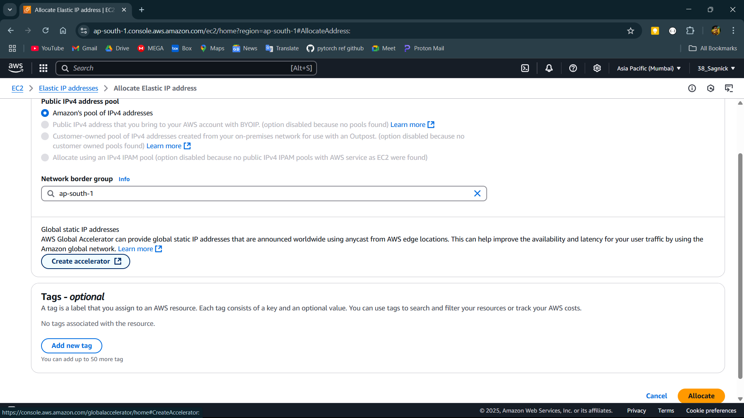

**Step-7:**

Now open the IP address and go to associate elastic IP address then select the instance and its private IP address then associate.

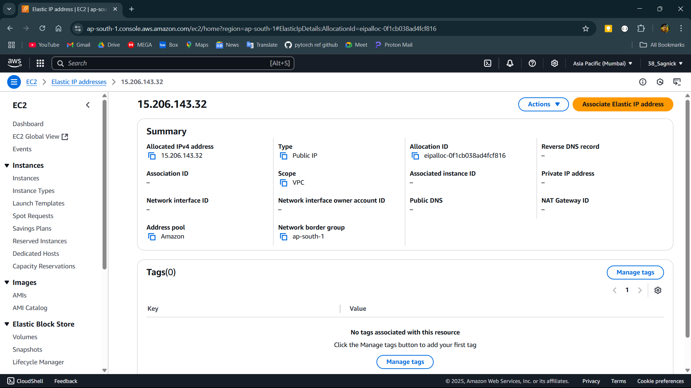

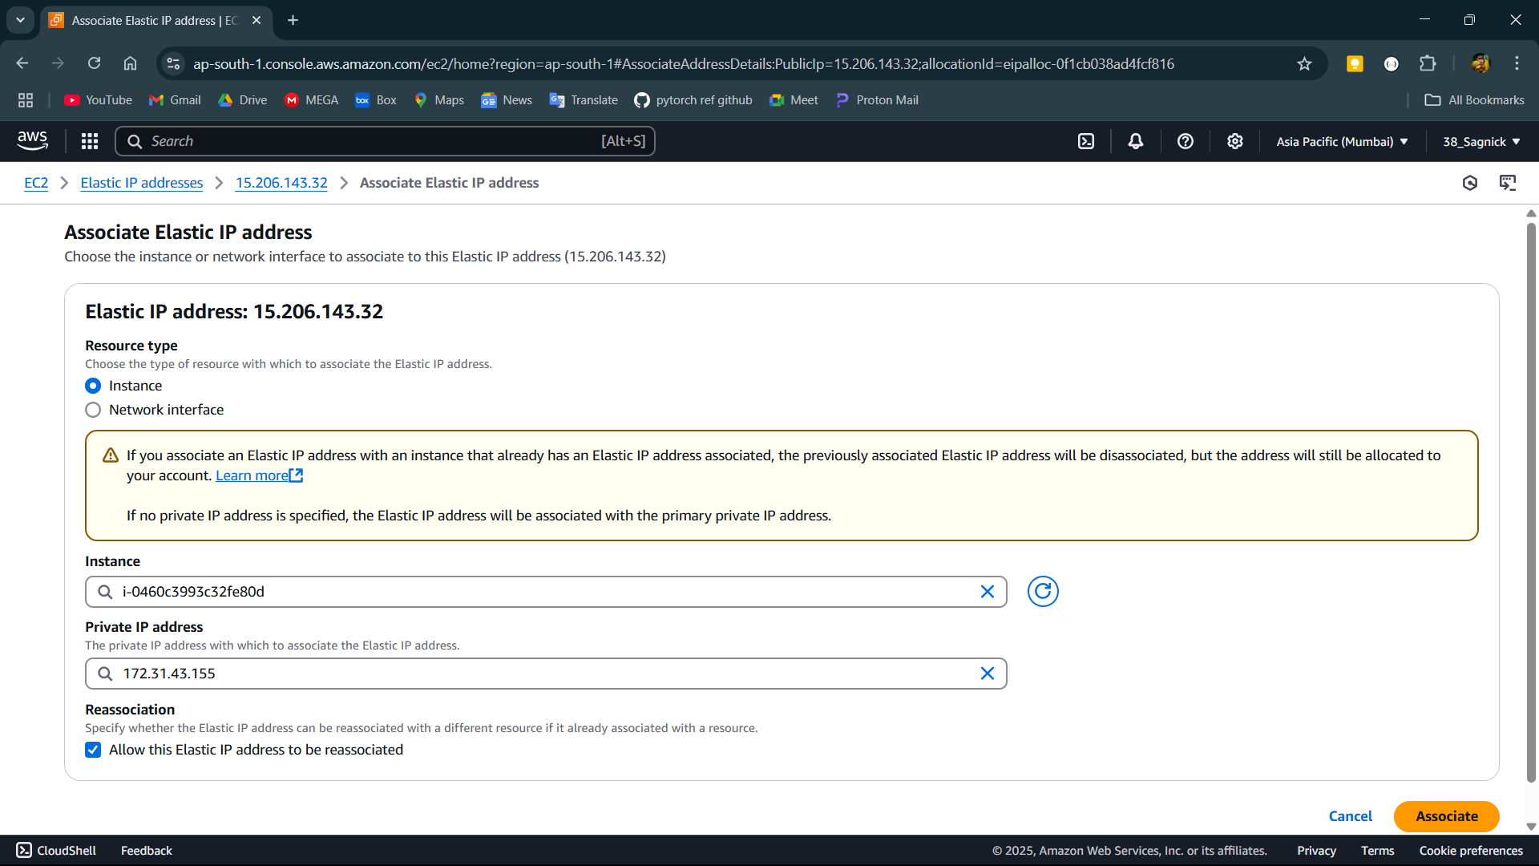

**Step-8:**

Now go back to the instance and the IP address is now changed to the address of the elastic IP and turning the instance off and on now does not changes the IP.

